

A brief history and description

Windows 1.0 (1985) was initially a front end for ms-dos developed by Microsoft. It simply provided a graphic environment for the platform. Iterations were made over the years improving on Windows 1.0. Until Windows NT 3.1 (1993). This version of windows was built from scratch as 32 bit operating system. This was the first time windows was released as a standalone operating system like it is today as Windows 10. Through incremental improvements and experimental features through version of windows, Microsoft has come to release Windows 10 in 2015.

Windows 10 is a 64-bit standalone operating system for computers and tablets. In terms of its user interface it has a strong focus on multitasking functionality, with the whole idea of having resizable “windows” where multiple task interfaces can fit in your screen and switching between these tasks is easy. It has a "task view” mode which allows you to switch between desktops and tasks.

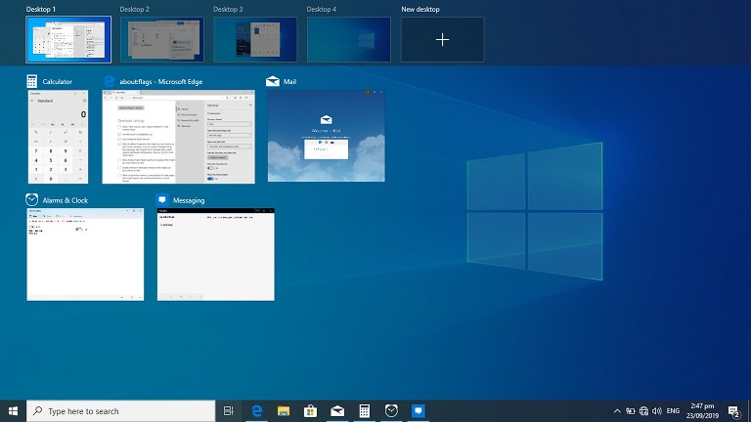

Process management

A program is a set of instructions. A process is an instance of execution of a program. A process is dynamic, its properties change as while it runs.

Processes require certain computer resources in order to run. For example, CPU time and some space in memory. There are many processes running on a system at any given time. All of them want access to system resources but system resources are limited. So it is the operating system’s job to manage processes. This is the premise of process management. Process management involves: the creation of processes, the ending of processes, scheduling processes and managing deadlocks that may occur.

Processes run on “threads” which allows them to operate independently of other processes. Process’s code and data will not be affected by other processes because each process has its own virtual address space.

Because windows supports multiprocessing, threads can be allocated to different processors in the systems to execute code simultaneously.

How windows 10 creates a process.

It runs a function called CreateProcess. There are parameters to this function. The function creates a new process with a single primary thread (the process may create more threads for itself).

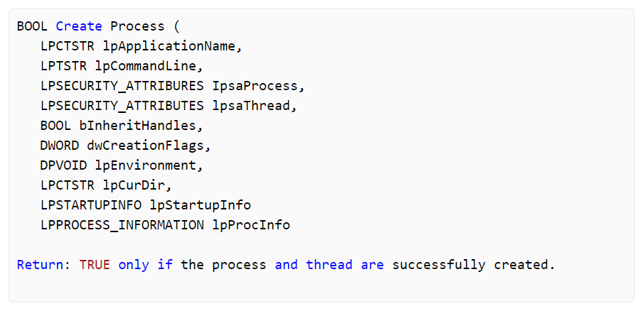

One of the biggest parts of process management in Windows 10 is the scheduler. Its job is to schedule time for processes to use the CPU. It stores all the processes in the operating system in the process table. The scheduler adds and removes processes to this table. The process table also includes a process’s: assigned memory location, priority and the state.

Then there is the dispatcher. It executes processes according to the schedule. It does this by process switching. This means that multiple processes can run “at the same time” even though the CPU can’t actually process everything simultaneously. It just swaps between them so fast that a user wouldn’t notice.

Memory management

Memory management is the operating system’s responsibility to co-ordinate the use of the system’s primary memory.

Windows manages what the system’s memory is allocated to. The same process cannot be allocated the same space in memory.

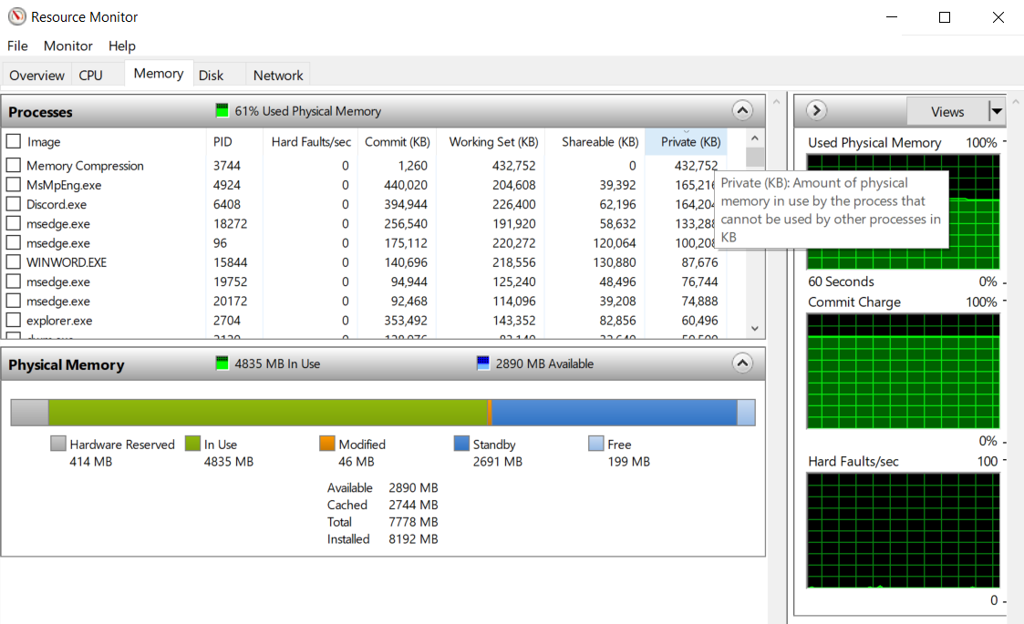*Image showing memory allocation in Windows 10.*

In the event that the system runs out of physical memory, Windows will create virtual memory using the secondary storage (e.g. A hard disk drive). Pages of data are shifted to and from the RAM and storage devices. This is slows down the system significantly due to the bottleneck of storages slower transfer rates but it is necessary to keep all the processes running.

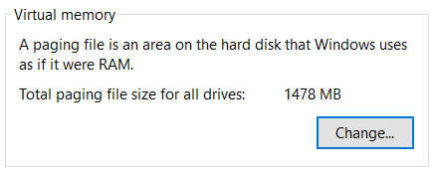

File management

File management is the operating system’s responsibility to co-ordinate the use of the system’s secondary storage. It provides hierarchical organization of files. It also creates file descriptors which are unique integers that represent an opened file. File descriptors are used to store information about an opened file.

In the image below you can see the Windows 10 file explorer. It shows the directory path and all the directories/files.

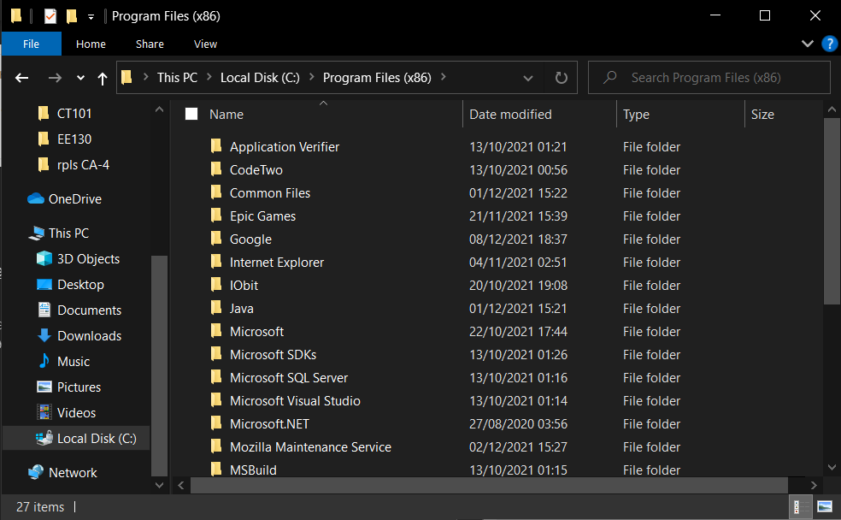

Device management

Device management is the operating system’s responsibility to manage the communication between system hardware/software and connected devices. Communication takes places thanks to device drivers. Windows needs to make sure the correct drivers are installed on the system so that the system can properly communicate with devices.

Below is an image showing the device manager in Windows 10. This is just the user interface for managing devices. Device management is much broader than this. And happens in the background. Plug and Play (PnP) is a big part of device management in Windows 10. When a new device is connected Windows scans for a driver package that matches the hardware identifiers provided from the device. Windows installs the most appropriate driver package(s) for the device. This is done automatically and in the background as soon as a new device is connected.

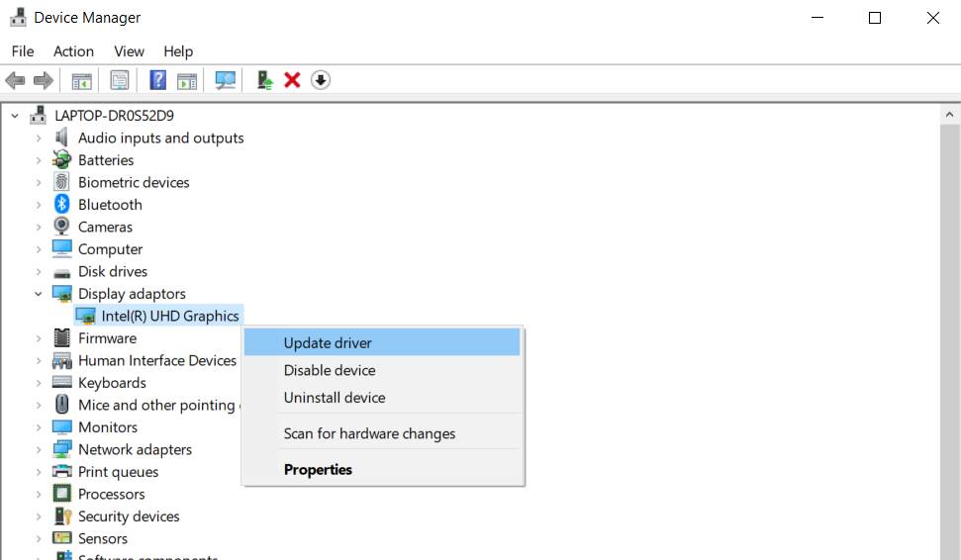

References

En.wikipedia.org. 2021. *Windows 10 - Wikipedia*. [online] Available at: <https://en.wikipedia.org/wiki/Windows_10> [Accessed 9 December 2021].

Hart, J., n.d. *Chapter 6: Process Management*. [online] Codemag.com. Available at: <https://www.codemag.com/Article/100113/Chapter-6-Process-Management> [Accessed 9 December 2021].

Hudek, T., 2021. *Step 2 A Driver for the Device is Selected - Windows drivers*. [online] Docs.microsoft.com. Available at: <https://docs.microsoft.com/en-us/windows-hardware/drivers/install/step-2--a-driver-for-the-device-is-selected> [Accessed 9 December 2021].

McCaskill, S., 2015. *Windows 10: A Brief History Of Windows*. [online] Silicon UK. Available at: <https://www.silicon.co.uk/workspace/windows-10-history-xp-nt-173691> [Accessed 2 December 2021].

Shukla, A., 2017. *Process management of operating system - IncludeHelp*. [online] Includehelp.com. Available at: <https://www.includehelp.com/operating-systems/process-management-of-operating-system.aspx> [Accessed 9 December 2021].

What are file descriptors, e., n.d. *What are file descriptors, explained in simple terms?*. [online] Stack Overflow. Available at: <https://stackoverflow.com/questions/5256599/what-are-file-descriptors-explained-in-simple-terms> [Accessed 9 December 2021].

Images

En.wikipedia.org. 2021. *Windows 10 - Wikipedia*. [online] Available at: <https://en.wikipedia.org/wiki/Windows_10> [Accessed 9 December 2021].

Hart, J., n.d. *Chapter 6: Process Management*. [online] Codemag.com. Available at: <https://www.codemag.com/Article/100113/Chapter-6-Process-Management> [Accessed 9 December 2021].  
  
Some images are screenshots from my computer running Windows 10.